Webex App Basic Guide
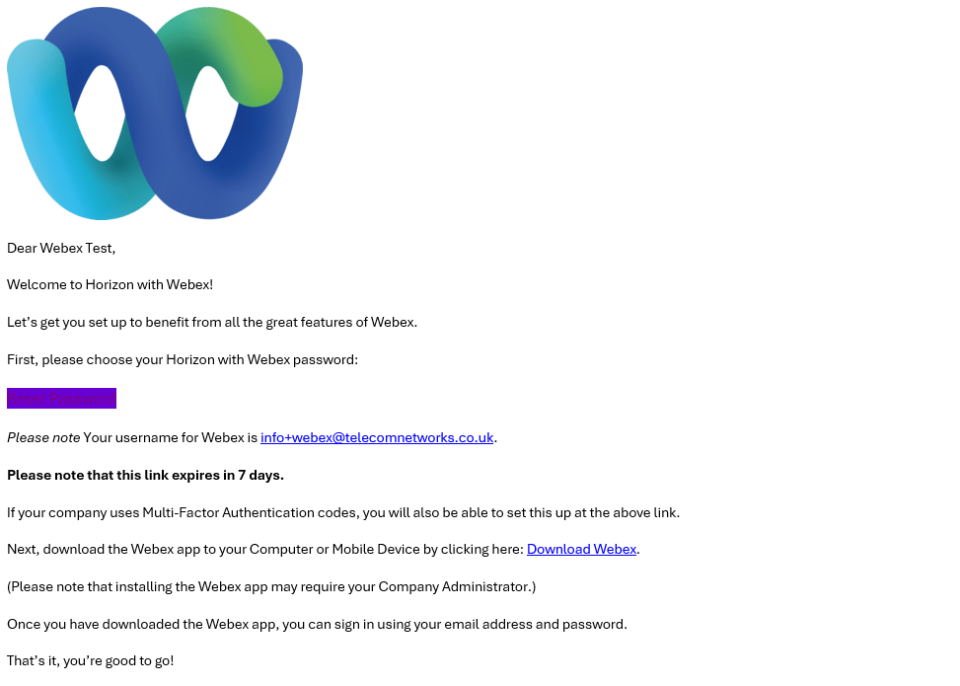

- Once onboarding email is received, please click on the link provided to ‘Reset Password’

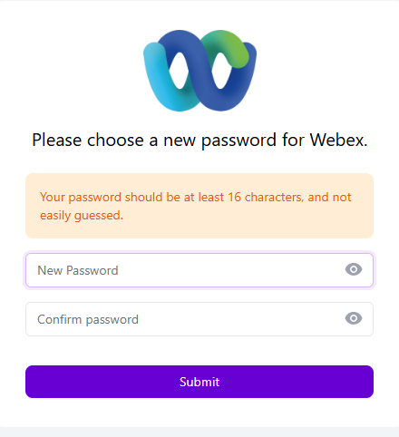

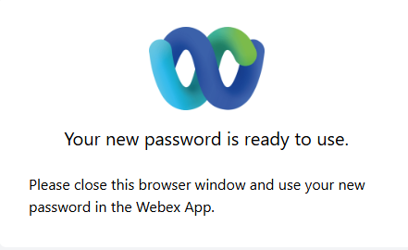
- Please reset and keep a note of the password in a safe place. The password requires to be 16 characters long. Press submit and you should receive the page below

- Download the Webex Cisco app from the app store on your mobile or desktop device. Once downloaded select ‘Sign In’ from the page below and input the username provided and your new password.
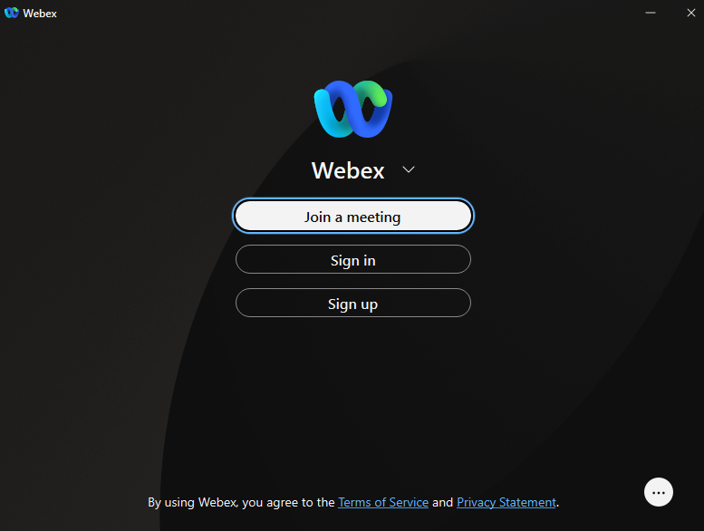

- Once logged in the below notification will show, press OK.

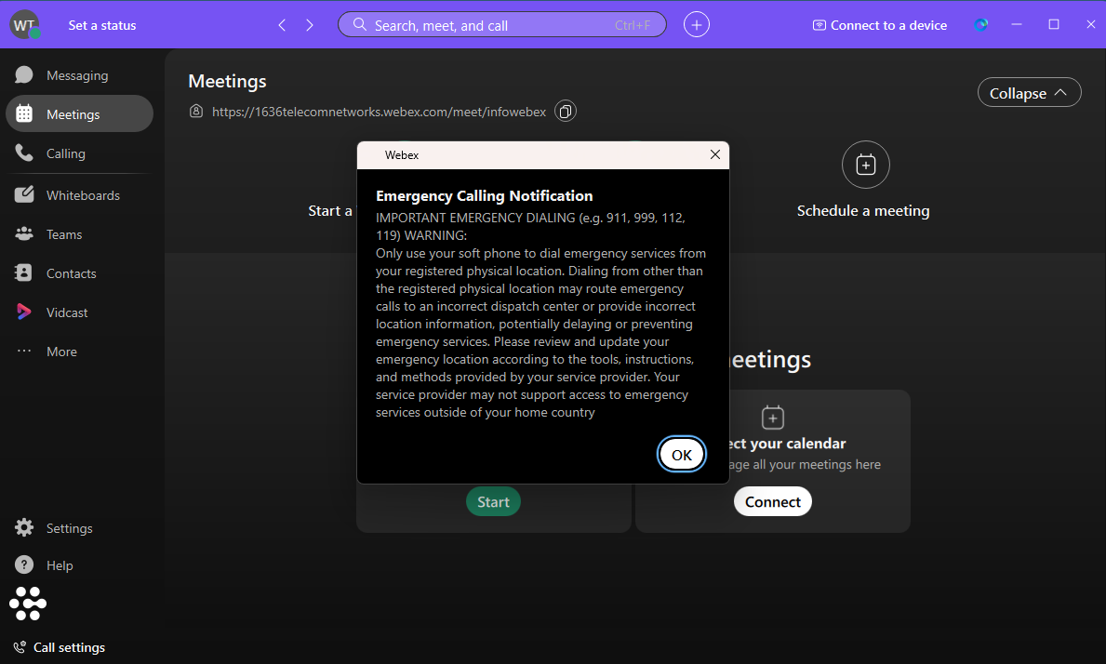

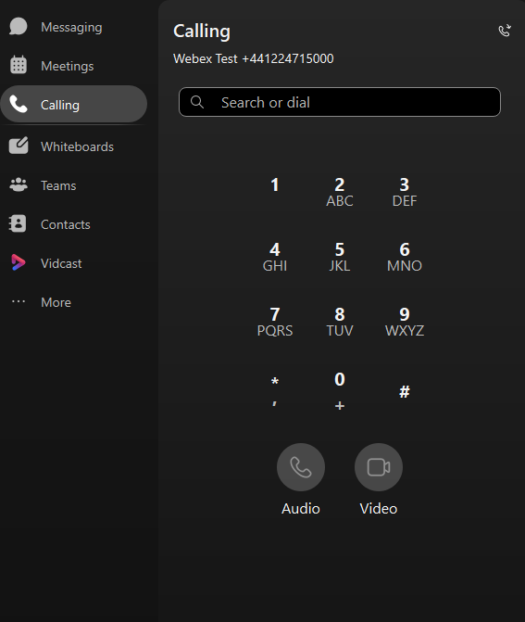

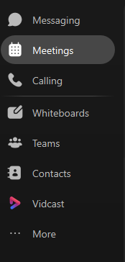
- Most used functions are located down the right hand side of the app in the black vertical box.

- The messaging function can be used to message other staff members within the company who are also using the Webex app. To send a message press the white add sign at the left-hand side of the menu.
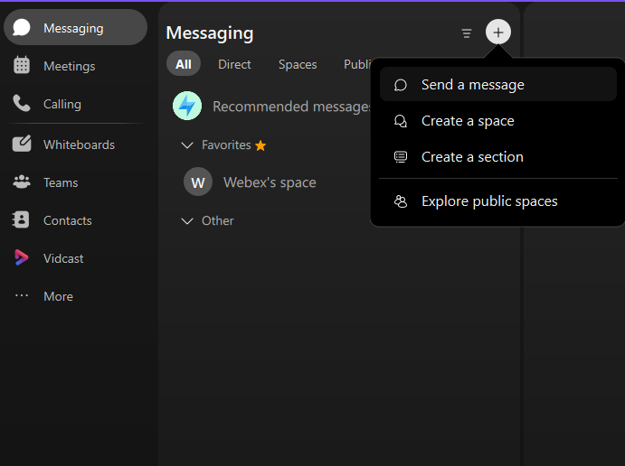

- To make a call on the app go to the ‘Calling’ Menu on the right-hand side. Here you can make calls using the dial pad or search function. You will also find the call history in this menu.
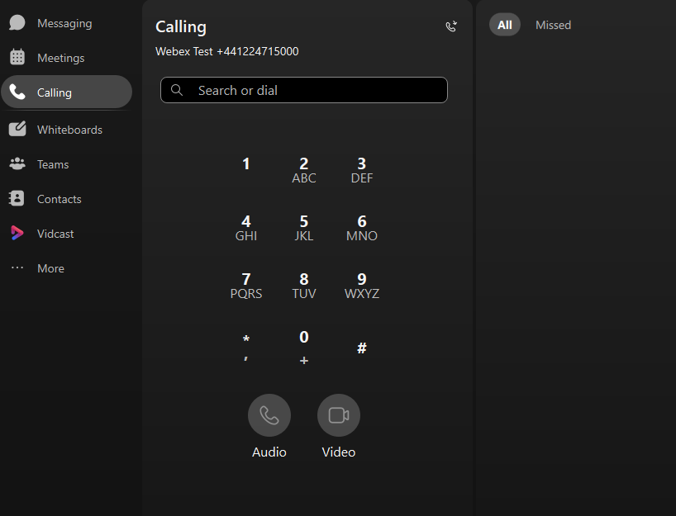

- To find contacts in the business directory go to the ‘Contacts’ section on the right-hand side. We do not recommend adding important business contacts to the directory yourself as this will only show on the Webex app. If the app were to be phased out these contacts will be lost if not input in the phone directory on the phone system. If there are additional contacts to be added please contact us on info@telecomnetoworks.co.uk.
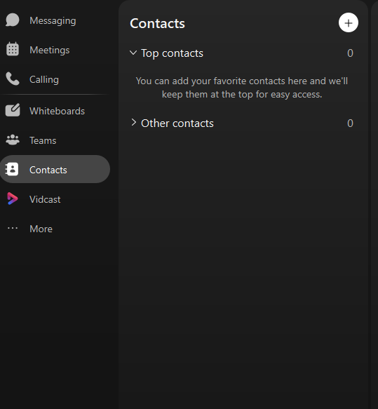

- To make changes to the user settings or availability please click on the initials on the top right-hand corner. Busy and Do not Disturb options will not allow calls to come through.

